**INSTALLING OPENCV AND RUNNING A SIMPLE PROJECT IN PYTHON**

**Step 1: Create a Project Folder**

First, open your terminal and create a new project folder. Navigate to that folder using the following commands:

|  |  |
| --- | --- |
| mkdir demo  cd demo |  |

**Step 2: Set Up a Virtual Environment**

Before installing any Python packages, it is recommended to set up a virtual environment. This helps keep project dependencies isolated and avoids conflicts with system-wide packages.

|  |  |
| --- | --- |
| To create a virtual environment, run:  python3 -m venv venv  This will create a new folder named venv inside your project directory. |  |

**Step 3: Activate the Virtual Environment**

To activate the virtual environment, use the appropriate command for your operating system:

* **Mac/Linux**: source venv/bin/activate
* **Windows**: venv\Scripts\activate

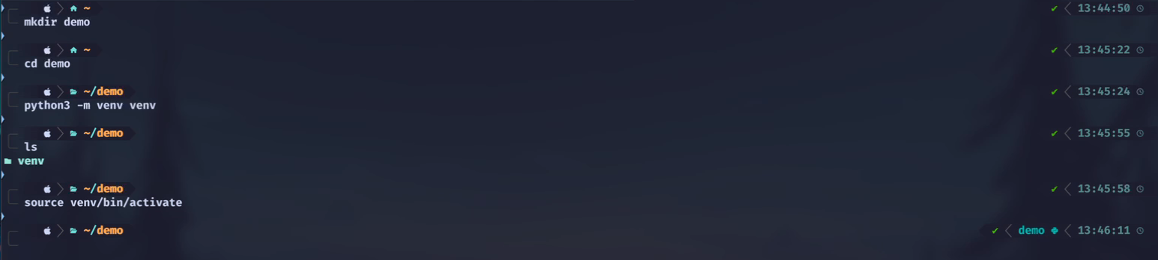

Once activated, any package installed will be contained within this virtual environment. You can see on the right-hand side, inside the virtual environment, the prompt changes. On the machine, it may not show this, but you can verify you are inside the virtual environment by running: deactivate

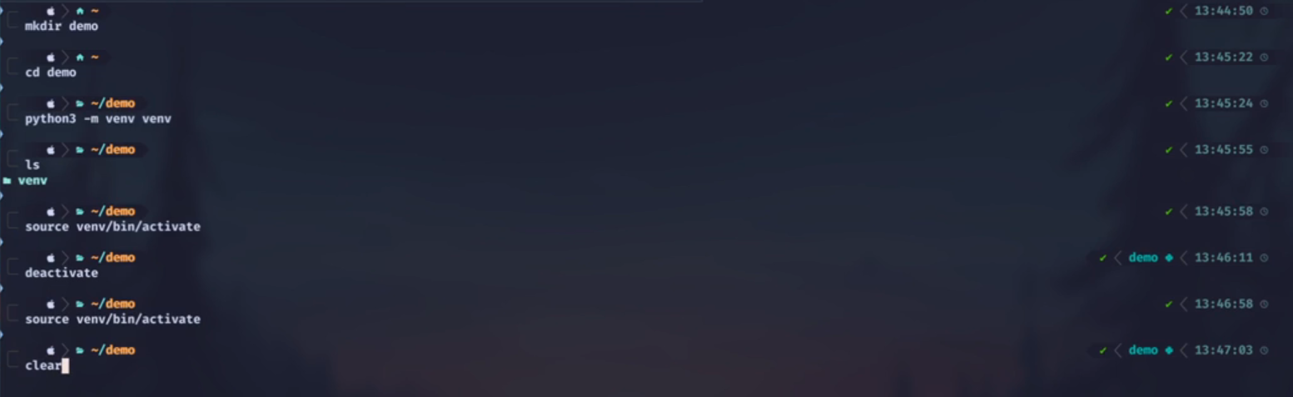

If the command auto-completes with Tab, then you are inside the virtual environment.

**Step 4: Install OpenCV**

|  |  |
| --- | --- |
| Next, install OpenCV using pip:  pip install opencv-python |  |

OpenCV will automatically install NumPy as a dependency, but you may need additional libraries such as matplotlib:

pip install matplotlib

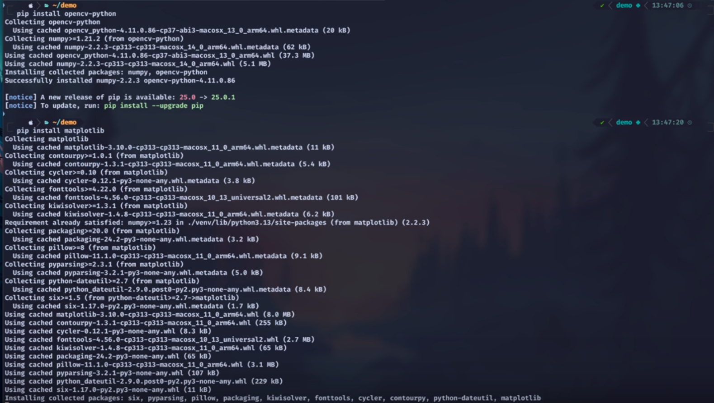

**Step 5: Start Writing Python Code**

After installing all the necessary packages, begin writing some Python code.

A new file will be created to include an example from the [OpenCV](https://docs.opencv.org/4.x/db/deb/tutorial_display_image.html) website.

This example will open a window displaying an image. If the 's' key is pressed, the file will be saved with a different extension. For instance, if the original file is a JPEG, pressing 's' will save it as a PNG.

|  |  |
| --- | --- |
| To begin, create a new Python file named test.py |  |

Adding the following code:

import cv2 as cv

import sys

img = cv.imread(cv.samples.findFile("starry_night.jpg"))

if img is None:

sys.exit("Could not read the image.")

cv.imshow("Display window", img)

k = cv.waitKey(0)

if k == ord("s"):

cv.imwrite("starry_night.png", img)

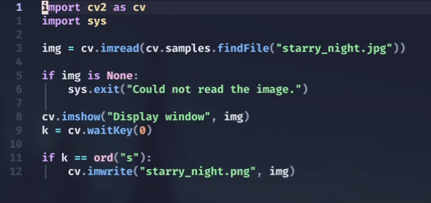

Currently, starry_night.jpg is not in the project directory. This file must be downloaded and moved into the folder before executing the script.

**Step 6: Get the Sample Image**

|  |  |
| --- | --- |
| Download starry_night.jpg from the [OpenCV GitHub](https://github.com/) repository and move it into your project folder. |  |

**Step 7: Run the Script**

Execute the Python script with: python3 test.py

After a little bit, the image will show up in a new window.

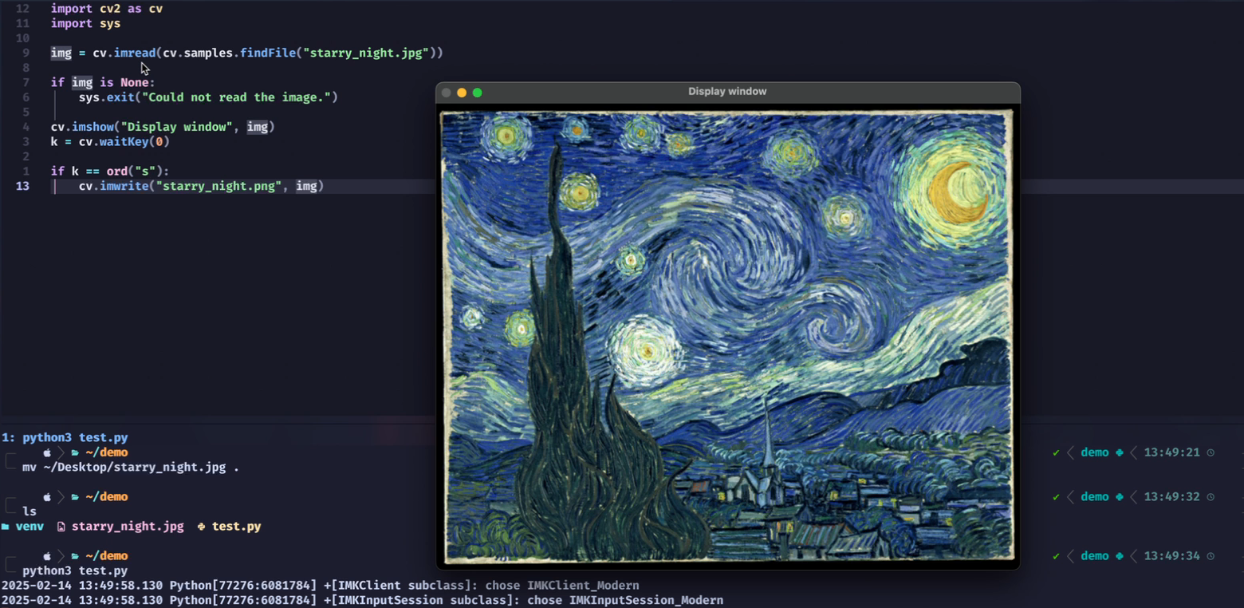

If the file does not exist, the program will throw an error and exit. Since we have the file, it will run successfully.

Using cv2.imread(), we read the file and store it in a variable.

Using cv2.imshow(), we display that image.

The cv2.waitKey() function:

* If set to 0, it will never close the window until you press a key.
* If set to 10, it will wait for 10 milliseconds and, if no key is pressed, move to the next step, which is saving the file.

Now, press the 's' key to save the file. If you hit 's', you will see a new file saved as starry_night_copy.png.

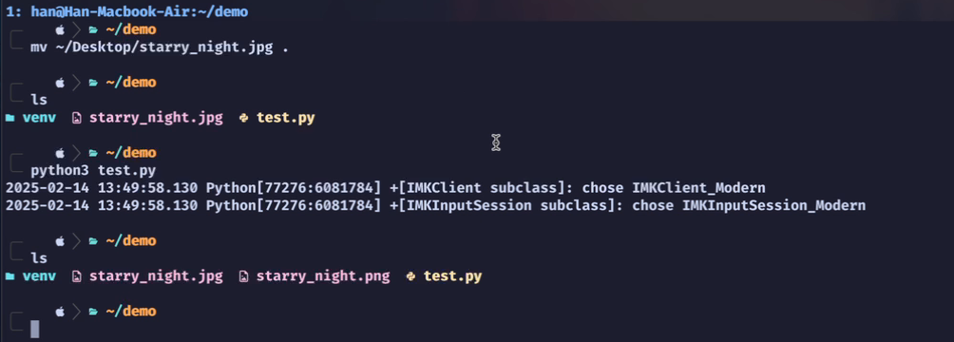

This is just the basic setup. You can explore [OpenCV](https://docs.opencv.org/4.x/db/deb/tutorial_display_image.html)’s documentation or work on more advanced projects.

**Step 8: Exit the Virtual Environment**

Once you're done, deactivate the virtual environment by running: deactivate

**Summary**

* Create a new virtual environment (python3 -m venv venv).
* Activate the virtual environment (source venv/bin/activate or venv\Scripts\activate).
* Install OpenCV (pip install opencv-python).
* Install additional packages if needed (pip install matplotlib).
* Create and run a Python script to display and save an image.
* Deactivate the virtual environment when finished (deactivate).

**Additional Notes**

Even though the package name is opencv-python, you import it as: import cv2

If you prefer, you can rename the import for shorter calls: import cv2 as cv

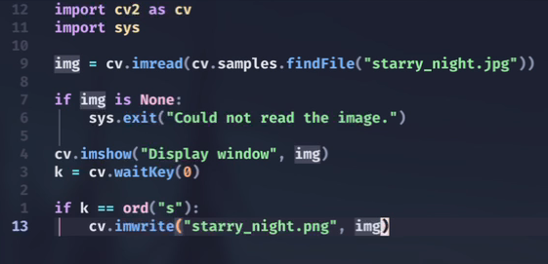

This helps simplify function calls within your script.

If you remain inside the virtual environment after finishing, simply run deactivate to exit.

That's it for this tutorial.